How to Build SQL Server 2019 DBA Real Time Home Lab   
in VMware workstation

**Hardware Minimum Requirements:**

Virtualization support in Bios

8 GB RAM

2.5 GH processer or More

500 HDD or 1TB HDD

**Other Requirements:**64 Bit OS (windows 7/8/10)

VMware workstation **or** Hyper v **or** Virtual Box

**My environment:**

32 GB Ram

1 TB SSD and 1 TB HDD

Intel with 4 physical cores with virtualization support (4x2=8Cores)

Windows 10 64 bit os

Vmware workstation 16.1.0

Demo Configuration:

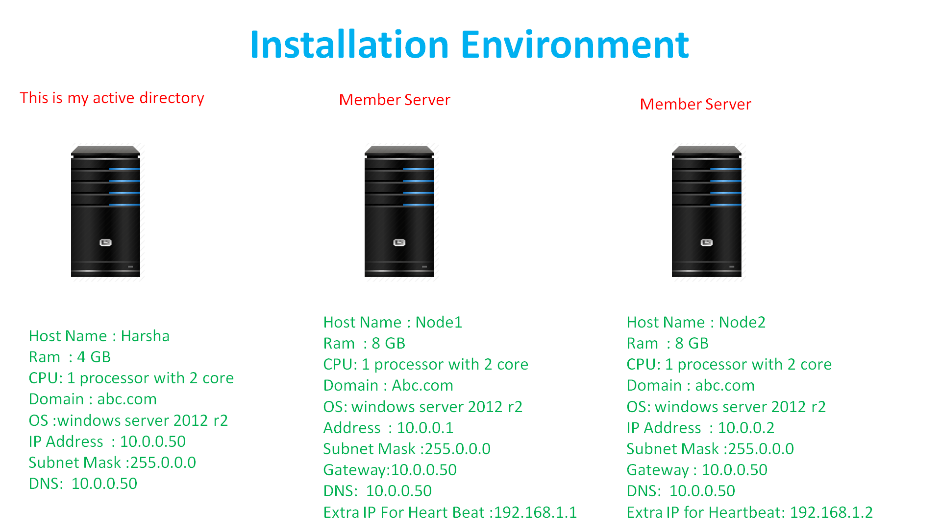

**Basics steps we need to check For Error Free installation**

1.All Member servers should be part of the Domain

2.Firewall should be off

3.Check communication between and Domain and member servers

4.Check Nslookup for all servers ( it means DNS is resolving hostname to IP and vice versa)

5.Login with Domain administrator or user which is having Domain Level Permissions every where

**Step By step:**

1.Enable Virtualization (VT) In BIOS

2.Install VMware workstation

3.Install 3 Windows Server OS

4.Disable IPv6 and configure IPs as shown in the demo environment Picture

4.Install Extra network adapter for node 2 & node 3 for heartbeat

5.Install Active Directory and configure Forword Lookup and Reverse Lookup Zones in Domain OS.

6.Disable the password complexity policy in domain

7.Disable the public,Private and domian firewalls rules in domian os.

8.Disable the public and private firewall rules in node 2 and node 3

9.Join the Node 1 and node 2 to domain.

11.Disable the domain firewall rule in node 2 and node3

12.Install .Net 3.5 Framework in Node 1 & Node 2

13.Install ISCSI Target Server and create Virtual Hardisks in domain and Assign to Node 1 & Node 2

14.Connect To ISCSI Target Through ISCSI Initiator and Assign Drive Letters (Note: Drive Letters Should Be same In Node 1 & Node 2

15.Install Failover clustering Feature In Node 1 & Node 2

16.Install Failover Cluster Automation Server Feature in Node 1 &  
 Node 2

18.Install ssms in node1 and node2

19.Install Standalone SQL Server 2014 with sql2019hyd01 in node1

20.Install Standalone SQL Server 2014 with sql2019hyd02 in node2

21.Enable Always On feature On Both Standalone Instances in Node 1 & Node 2 and configure Always on

22.Create and Validate Cluster

23.Install SQL failover cluster in node1 with (sql201901)

24.Install SQL Server With add a node to cluster Option in Node2 {Note :This works as Active - Passive SQL Cluster}

25.Install SQL failover cluster in node1 with (sql201902)

26.Install SQL Server With add a node to cluster Option in Node2 {Note :This works as Active - Active SQL Cluster}

27.Restore Any Sample Databases like Adventure works or North wind for Replication Practical

28.Configure Log shipping , Mirroring & Transactional Replication

Note: Like The Video

Comment Your Ideas and Doubts

Share the video If you like

**All The Best**